[[ASRock](http://www.asrock.com/index.asp)](http://www.asrock.com/index.asp)

http://www.asrock.com/images/b800-789.gif

**ION 3D Series**

|  |  |
| --- | --- |
| [http://www.asrock.com/nettop/photo/ION%203D%20Series.jpg](http://www.asrock.com/nettop/photo/ION%203D%20Series(m).jpg)  http://www.asrock.com/nettop/sticker/NVIDIA-3DTV(s).jpg | [Bookmark and Share](http://www.addthis.com/bookmark.php?v=250&username=asrock)|[Translate](http://www.addthis.com/bookmark.php?v=250&winname=addthis&pub=asrock&source=tbx-250&lng=nl&s=googletranslate&url=http%3A%2F%2Fwww.asrock.com%2Fnettop%2Foverview.asp%3FModel%3DION%203D%20Series&title=ASRock%20%3E%20Products%20%3E%20ION%203D%20Series&ate=AT-asrock/-/-/4e48e67d8a4bd1dd/11&frommenu=1&uid=4e48e67d536d3a0e&ct=1&pre=http%3A%2F%2Ftweakers.net%2Fpricewatch%2F270652%2Fasrock-ion-3d-152d-(zwart).html&tt=0)   * Intel® Atom™ D525 Dual Core Processor * Mobile Intel® ICH8M chipset * 2GB DDR2 800MHz * NVIDIA® GT218-ION Graphics, NVIDIA® 3DTV Play Capable * 7.1 CH HD Audio with DTS * [http://www.asrock.com/nettop/photo/ION%203D%20Series-1.jpg](http://www.asrock.com/nettop/photo/ION%203D%20Series-1(m).jpg) * [http://www.asrock.com/nettop/photo/ION%203D%20Series-2.jpg](http://www.asrock.com/nettop/photo/ION%203D%20Series-2(m).jpg) * [http://www.asrock.com/nettop/photo/ION%203D%20Series-3.jpg](http://www.asrock.com/nettop/photo/ION%203D%20Series-3(m).jpg)   Note: Below specifications may differ from areas and change without notice. Please check the specific specifications with your local dealers. |

**Features**

http://www.asrock.com/images/bg-790-top.gif

**NVIDIA® 3DTV Play**

http://www.asrock.com/images/bg-790-bottom.gif

NVIDIA® 3DTV Play allows you to leverage the 3D processing power of your GeForce GPU to create an immersive 3D experience in your own home. Convert over 475 of the most popular PC games into immersive 3D environments. And photos never looked so real. Bring home the 3D theatre experience and surround yourself in the latest Blu-ray 3D movies. Relive the moments captured in your 3D photos as you browse them on your HDMI 1.4a 3D TV or view them as a slideshow.

http://www.asrock.com/images/bg-790-top.gif

**3D Movie / Photo**

http://www.asrock.com/images/bg-790-bottom.gif

ASRock ION 3D HTPC Series deliver the terrific viewing experience. It has a powerful build-in Next-Generation ION graphics which supports 3D display, allowing user to enjoy a vivid 3D entertainment experience! With its amazing 3D display capability, you are able to experience the highest quality movie like never before!

http://www.asrock.com/images/bg-790-top.gif

**Low-power Intel® Atom™ D525 Dual Core CPU**

http://www.asrock.com/images/bg-790-bottom.gif

Intel® Atom™ D525 CPU processor-based ION 3D HTPC series offer both an easy-to-use mobile device with simple interfaces and targeted performance for a good energy saving experience.

http://www.asrock.com/images/bg-790-top.gif

**Next-generation NVIDIA® ION™ Graphics Architecture**

http://www.asrock.com/images/bg-790-bottom.gif

ASRock ION 3D Series support next-generation NVIDIA® ION™ graphics technology which is well-known for its outstanding graphics performance. ASRock ION 3D Series enable you to immerse in a qualified movie and video phenomenon.

http://www.asrock.com/images/bg-790-top.gif

**SuperSpeed USB3.0 HTPC System**

http://www.asrock.com/images/bg-790-bottom.gif

ASRock ION 3D HTPC series come with 2 x USB3.0 ports which deliver data transfer rates up to 10X faster than USB2.0 with the optimized power efficiency. USB3.0 promises a major leap forward in transfer speeds and capacity.

http://www.asrock.com/images/bg-790-top.gif

**Native Full HD 1080p playback**

http://www.asrock.com/images/bg-790-bottom.gif

Supporting Full HD 1080p playback, ASRock HTPC series give you "better than cinema" quality and the ultimate movie experience in the comfort of your own home!

http://www.asrock.com/images/bg-790-top.gif

**dts**

http://www.asrock.com/images/bg-790-bottom.gif

Get the Cinema-Style Sound from your PC! With DTS, ASRock ION 3D series let you enjoy a better way of experiencing music, movies and games. It delivers the advanced and excellent audio quality, enables you to hear every detail in riveting surround sound.

http://www.asrock.com/images/bg-790-top.gif

**1T2R 802.11n Wireless Networking**

http://www.asrock.com/images/bg-790-bottom.gif

Supporting two-way transmission direction, WiFi 802.11n provides a wider bandwidth to cover longer distance coverage.  
  
* ION 3D 152D / ION 3D 152B only.

http://www.asrock.com/images/bg-790-top.gif

**MCE Remote Controller**

http://www.asrock.com/images/bg-790-bottom.gif

ASRock MCE Remote Controller is exclusively able to power on the system at the first time of the plug-in of AC power. It prides itself on delivering a fast, intuitive, convenient and rich media experience for the multimedia entertainments.  
  
* ION 3D 152D / ION 3D 152B only.

http://www.asrock.com/images/bg-790-top.gif

**BD (Blu-ray Disc) Combo**

http://www.asrock.com/images/bg-790-bottom.gif

BD Combo which not only supports Blu-ray disc, but also capable of burning and reading DVD and CD. It definitely brings you the efficient, stable data transfer, the dazzling audio and visual experience.  
  
* ION 3D 152B only.

http://www.asrock.com/images/bg-790-top.gif

**HDMI 1.4a**

http://www.asrock.com/images/bg-790-bottom.gif

ASRock ION 3D HTPC series support onboard HDMI 1.4a output which support 3D formats for broadcast and movie content.

http://www.asrock.com/images/bg-790-top.gif

**Dual Link DVI**

http://www.asrock.com/images/bg-790-bottom.gif

With Dual Link DVI support, ASRock ION 3D HTPC Series support Blu-ray 3D Playback for your fantastic 3D experience. Supporting 120 Hz monitor with max. resolution up to 1920x1080(16:9) and 1920x1200(16:10); 60 Hz monitor with max. resolution up to 2560x1600.

http://www.asrock.com/images/bg-790-top.gif

**ASRock App Charger**

http://www.asrock.com/images/bg-790-bottom.gif

ASRock App Charger allows you to quickly charge your iPhone and even supports continuous charging even your PC is shutting down.

http://www.asrock.com/images/bg-790-top.gif

**ASRock AIWI - Turn Your iPhone Into Game Joystick**

http://www.asrock.com/images/bg-790-bottom.gif

Using AIWI to connect your apple devices to ASRock HTPC system, and you can interact with the PC games with delicate touches and body motion while getting responsive shakes and vibrations that correspond from the game stores.

**Awards**

http://www.asrock.com/news/award/kitguru.net-MustHave.gifhttp://www.asrock.com/news/award/PC-treiber(Golden).gifhttp://www.asrock.com/news/award/TweakTown(Features).gifhttp://www.asrock.com/news/award/pureoverclock.com-Editor.gif

10/28/2010 [**KitGURU** - Must Have](http://www.kitguru.net/desktop-pc/zardon/asrock-ion3d-152b-with-bluray-review-featuring-cyberlink/)  
The ASRock ION 3D looks great and consumes less power. An exceptional product and a great media choice for a living or bedroom environment. ASRock ION 3D received "MUST HAVE Award" from KitGURU.

**Product Introduction**

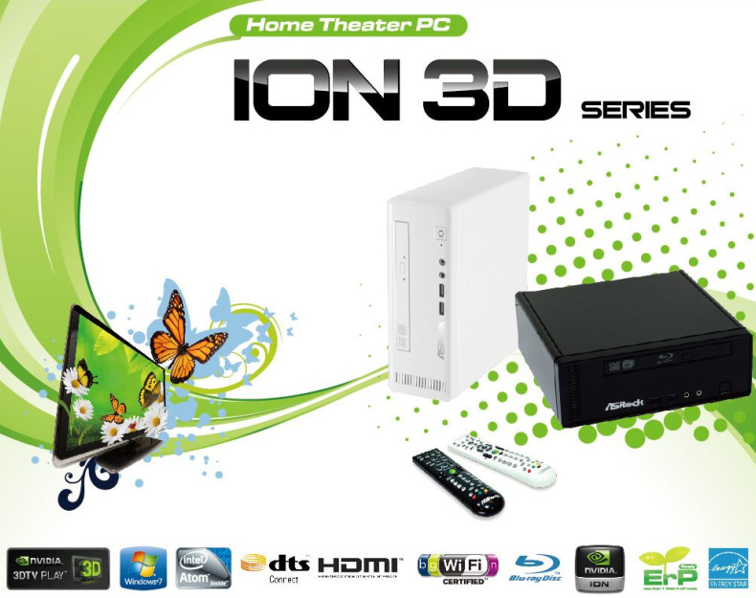

**dts**

Supporting industry's leading audio solution of the DTS Connect, ASRock ION 3D brings the cinema quality sound for your HTPC. With more personal computers being used as home media centers, DTS Connect is the perfect solution to enhance your entertainment experience by using your home theater's Audio/Video receiver. To deliver the best quality sound for users, ASRock ION 3D supports 7.1 CH HD Audio with DTS Connect technology, it will surely be your perfect choice for a professional HTPC.

**http://www.asrock.com/nettop/images/HDMI.gifHDMI 1.4a**

Keeping you in tune with life, the ASRock ION 3D allows users to enjoy the next dimension in HTPC entertainment. ASRock ION 3D is equipped with HDMI 1.4a output which supports 3D formats for movie and game.

**USB3.0**

Supporting data transfer rate up to 5Gb/s and 10X faster than USB2.0 with optimized power efficiency. USB3.0 promises a major leap forward transfer speed and capacity.

**ASRock AIWI**

Turn Your iPhone Into Gamejoystick

Wanna play PC games like Wii? ASRock AIWI software makes your dreams come true! Using ASRock AIWI to connect your apple devices to the ASRock HTPC via WLAN, then you can interact with PC games with delicate touches and body motion while getting responsive shakes and vibrations that correspond to the game stores.

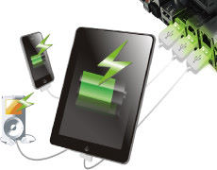**ASRock App Charger**

Fast Charge & Charge Anytime

Simply installing the App Charger driver, it makes your iPhone charge up to 40% faster than before. ASRock App Charger supports continuous charging when your PC enters Standby mode (S1), Suspend to RAM (S3), hibernation mode (S4) or power off (S5). The App Charger technology has been fully applied on ASRock Full series motherboards.

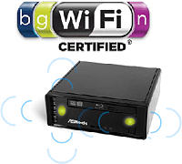**High speed 1T2R WiFi 802.11n**

ASRock ION 3D series mini HTPC is equipped with two invisible antennas (placed in a vertical/horizontal position) hidden inside the front panel, which provide larger signal coverage and faster connection speed. With the unrestricted-direction antennas design, the HTPC can be used as the wireless network receiver, as well as the network bandwidth sharing device. ASRock ION 3D series support 802.11n wireless network which provide better signal coverage and faster speed than ordinary network sharing devices.

**Mini Size and Silent Operation**

Mini size. Ultra silence. ASRock ION 3D has a volume of 2.5 liters only, which enables you to put inside the TV cabinet and connect it with LCD TV. Running a silent operation which is merely 24.1dB, ION 3D HTPC series ensure you an ultra silent computing environment as well.

**Low Power Consumption**

ASRock ION 3D series is an eco-friendly HTPC that reduces electricity cost through the unique power-saving components. Compared with desktop computer, ASRock ION 3D produces lower power consumption (merely 27W) and saves more power as well as electricity cost.

**Ultra Durable**

By using of 100% Japan-made high-quality conductive polymer capacitors which can extend the system life to at least 2.5 longer, ASRock ION 3D HTPC series provide the stability, reliability and longevity essential to meet the power, processor, and other components needs for running today’s most demanding applications and games.

**Software Suite**

**ASRock Software Suite**

ASRock Software suite, offers a string of user-friendly software, ensures you will have the rich operating experience.

**ASRock AIWI**

Turn Your iPhone Into Gamejoystick

Wanna play PC games like Wii? ASRock AIWI software makes your dreams come true! Using ASRock AIWI to connect your apple devices to the ASRock HTPC via WLAN, then you can interact with the PC games with delicate touches and body motion while getting responsive shakes and vibrations that correspond from the game stores.

**NVIDIA® 3DTV Play**

NVIDIA® 3DTV Play allows you to leverage the 3D processing power of your GeForce GPU to create an immersive 3D experience in your own home. Convert over 475 of the most popular PC games into immersive 3D environments. And photos never looked so real. Bring home the 3D theatre experience and surround yourself in the latest Blu-ray 3D movies. Relive the moments captured in your 3D photos as you browse them on your HDMI 1.4a 3D TV or view them as a slideshow.

**CyberLink DVD Suite - OEM & Trial**

**CyberLink Power2Go 6.1 LE - OEM**, is the All-Media Disc Burning software which offers a hassle-free approach to burn, backup videos, photos, music and data onto Blu-ray Discs and DVDs.

**CyberLink MediaShow 4.1 SE - OEM**, is a fast and easy way to preserve and share your life’s best moments. It has a string of features such as one-click fixes, face tagging.. etc and provides a convenient way for organizing and sharing your photos and videos.

**CyberLink PowerDVD 8.0 DTS - Trial**, world-renowned PowerDVD 8 DTS delivers outstanding DVD movie playback quality on your PC.

**CyberLink PowerDirector 8.0 - Trial**, is a powerful video editing tool with unlimited possibilities. It offers more, video enhancement and editing tools, enables you to edit high-definition videos including AVCHD, and allows output to PSP iPod and Blu-ray Disc.

**CyberLink PowerBackup 2.5 - Trial**, provides the safest way to protect your valuable data. With this, you will no need to worry about the data damage or loss anymore.

**Accessories**

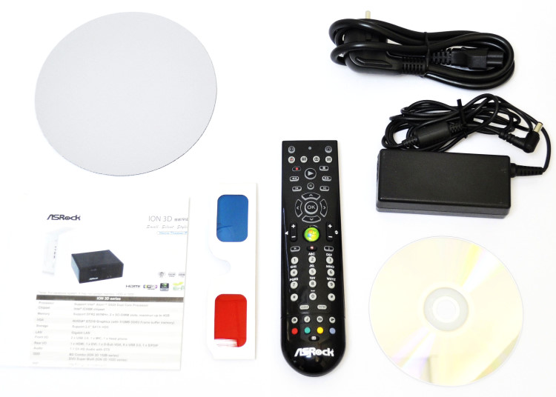

**Product Specifications**

|  |  |
| --- | --- |
|  |  |

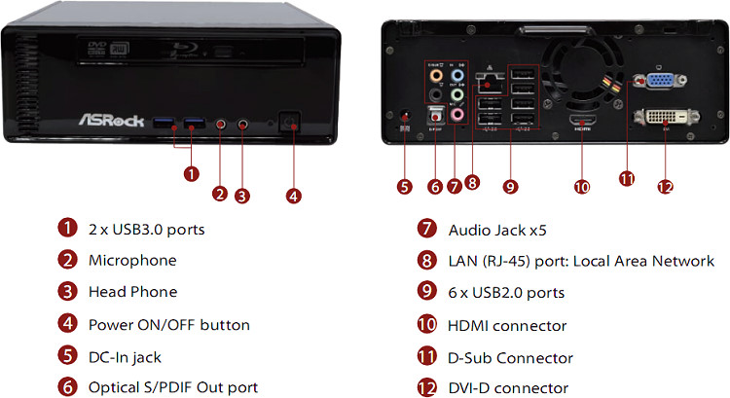

## Features

http://www.asrock.com/images/bg-790-top.gif

**NVIDIA® 3DTV Play**

http://www.asrock.com/images/bg-790-bottom.gif

NVIDIA® 3DTV Play allows you to leverage the 3D processing power of your GeForce GPU to create an immersive 3D experience in your own home. Convert over 475 of the most popular PC games into immersive 3D environments. And photos never looked so real. Bring home the 3D theatre experience and surround yourself in the latest Blu-ray 3D movies. Relive the moments captured in your 3D photos as you browse them on your HDMI 1.4a 3D TV or view them as a slideshow.

http://www.asrock.com/images/bg-790-top.gif

**3D Movie / Photo**

http://www.asrock.com/images/bg-790-bottom.gif

ASRock ION 3D HTPC Series deliver the terrific viewing experience. It has a powerful build-in Next-Generation ION graphics which supports 3D display, allowing user to enjoy a vivid 3D entertainment experience! With its amazing 3D display capability, you are able to experience the highest quality movie like never before!

http://www.asrock.com/images/bg-790-top.gif

**Low-power Intel® Atom™ D525 Dual Core CPU**

http://www.asrock.com/images/bg-790-bottom.gif

Intel® Atom™ D525 CPU processor-based ION 3D HTPC series offer both an easy-to-use mobile device with simple interfaces and targeted performance for a good energy saving experience.

http://www.asrock.com/images/bg-790-top.gif

**Next-generation NVIDIA® ION™ Graphics Architecture**

http://www.asrock.com/images/bg-790-bottom.gif

ASRock ION 3D Series support next-generation NVIDIA® ION™ graphics technology which is well-known for its outstanding graphics performance. ASRock ION 3D Series enable you to immerse in a qualified movie and video phenomenon.

http://www.asrock.com/images/bg-790-top.gif

**SuperSpeed USB3.0 HTPC System**

http://www.asrock.com/images/bg-790-bottom.gif

ASRock ION 3D HTPC series come with 2 x USB3.0 ports which deliver data transfer rates up to 10X faster than USB2.0 with the optimized power efficiency. USB3.0 promises a major leap forward in transfer speeds and capacity.

http://www.asrock.com/images/bg-790-top.gif

**Native Full HD 1080p playback**

http://www.asrock.com/images/bg-790-bottom.gif

Supporting Full HD 1080p playback, ASRock HTPC series give you "better than cinema" quality and the ultimate movie experience in the comfort of your own home!

http://www.asrock.com/images/bg-790-top.gif

**dts**

http://www.asrock.com/images/bg-790-bottom.gif

Get the Cinema-Style Sound from your PC! With DTS, ASRock ION 3D series let you enjoy a better way of experiencing music, movies and games. It delivers the advanced and excellent audio quality, enables you to hear every detail in riveting surround sound.

http://www.asrock.com/images/bg-790-top.gif

**1T2R 802.11n Wireless Networking**

http://www.asrock.com/images/bg-790-bottom.gif

Supporting two-way transmission direction, WiFi 802.11n provides a wider bandwidth to cover longer distance coverage.  
  
* ION 3D 152D / ION 3D 152B only.

http://www.asrock.com/images/bg-790-top.gif

**MCE Remote Controller**

http://www.asrock.com/images/bg-790-bottom.gif

ASRock MCE Remote Controller is exclusively able to power on the system at the first time of the plug-in of AC power. It prides itself on delivering a fast, intuitive, convenient and rich media experience for the multimedia entertainments.  
  
* ION 3D 152D / ION 3D 152B only.

http://www.asrock.com/images/bg-790-top.gif

**BD (Blu-ray Disc) Combo**

http://www.asrock.com/images/bg-790-bottom.gif

BD Combo which not only supports Blu-ray disc, but also capable of burning and reading DVD and CD. It definitely brings you the efficient, stable data transfer, the dazzling audio and visual experience.  
  
* ION 3D 152B only.

http://www.asrock.com/images/bg-790-top.gif

**HDMI 1.4a**

http://www.asrock.com/images/bg-790-bottom.gif

ASRock ION 3D HTPC series support onboard HDMI 1.4a output which support 3D formats for broadcast and movie content.

http://www.asrock.com/images/bg-790-top.gif

**Dual Link DVI**

http://www.asrock.com/images/bg-790-bottom.gif

With Dual Link DVI support, ASRock ION 3D HTPC Series support Blu-ray 3D Playback for your fantastic 3D experience. Supporting 120 Hz monitor with max. resolution up to 1920x1080(16:9) and 1920x1200(16:10); 60 Hz monitor with max. resolution up to 2560x1600.

http://www.asrock.com/images/bg-790-top.gif

**ASRock App Charger**

http://www.asrock.com/images/bg-790-bottom.gif

ASRock App Charger allows you to quickly charge your iPhone and even supports continuous charging even your PC is shutting down.

http://www.asrock.com/images/bg-790-top.gif

**ASRock AIWI - Turn Your iPhone Into Game Joystick**

http://www.asrock.com/images/bg-790-bottom.gif

Using AIWI to connect your apple devices to ASRock HTPC system, and you can interact with the PC games with delicate touches and body motion while getting responsive shakes and vibrations that correspond from the game stores.

## Awards

http://www.asrock.com/news/award/kitguru.net-MustHave.gifhttp://www.asrock.com/news/award/PC-treiber(Golden).gifhttp://www.asrock.com/news/award/TweakTown(Features).gifhttp://www.asrock.com/news/award/pureoverclock.com-Editor.gif

12/9/2010 [**TweakTown** - Best Features](http://www.tweaktown.com/reviews/3702/quick_review_asrock_ion_3d_152b_intel_atom_d525_htpc_with_nvidia_3dtv_play/index.html)  
For those who are looking at adding 3D to their office or even lounge room, the ASRock ION 3D HTPC is a solid choice! ASRock ION 3D HTPC received Best Features Award from TweakTown.

## Product Introduction



dts

Supporting industry's leading audio solution of the DTS Connect, ASRock ION 3D brings the cinema quality sound for your HTPC. With more personal computers being used as home media centers, DTS Connect is the perfect solution to enhance your entertainment experience by using your home theater's Audio/Video receiver. To deliver the best quality sound for users, ASRock ION 3D supports 7.1 CH HD Audio with DTS Connect technology, it will surely be your perfect choice for a professional HTPC.

http://www.asrock.com/nettop/images/HDMI.gifHDMI 1.4a

Keeping you in tune with life, the ASRock ION 3D allows users to enjoy the next dimension in HTPC entertainment. ASRock ION 3D is equipped with HDMI 1.4a output which supports 3D formats for movie and game.

USB3.0

Supporting data transfer rate up to 5Gb/s and 10X faster than USB2.0 with optimized power efficiency. USB3.0 promises a major leap forward transfer speed and capacity.

ASRock AIWI

Turn Your iPhone Into Gamejoystick

Wanna play PC games like Wii? ASRock AIWI software makes your dreams come true! Using ASRock AIWI to connect your apple devices to the ASRock HTPC via WLAN, then you can interact with PC games with delicate touches and body motion while getting responsive shakes and vibrations that correspond to the game stores.

ASRock App Charger

Fast Charge & Charge Anytime

Simply installing the App Charger driver, it makes your iPhone charge up to 40% faster than before. ASRock App Charger supports continuous charging when your PC enters Standby mode (S1), Suspend to RAM (S3), hibernation mode (S4) or power off (S5). The App Charger technology has been fully applied on ASRock Full series motherboards.

High speed 1T2R WiFi 802.11n

ASRock ION 3D series mini HTPC is equipped with two invisible antennas (placed in a vertical/horizontal position) hidden inside the front panel, which provide larger signal coverage and faster connection speed. With the unrestricted-direction antennas design, the HTPC can be used as the wireless network receiver, as well as the network bandwidth sharing device. ASRock ION 3D series support 802.11n wireless network which provide better signal coverage and faster speed than ordinary network sharing devices.

Mini Size and Silent Operation

Mini size. Ultra silence. ASRock ION 3D has a volume of 2.5 liters only, which enables you to put inside the TV cabinet and connect it with LCD TV. Running a silent operation which is merely 24.1dB, ION 3D HTPC series ensure you an ultra silent computing environment as well.

Low Power Consumption

ASRock ION 3D series is an eco-friendly HTPC that reduces electricity cost through the unique power-saving components. Compared with desktop computer, ASRock ION 3D produces lower power consumption (merely 27W) and saves more power as well as electricity cost.

Ultra Durable

By using of 100% Japan-made high-quality conductive polymer capacitors which can extend the system life to at least 2.5 longer, ASRock ION 3D HTPC series provide the stability, reliability and longevity essential to meet the power, processor, and other components needs for running today’s most demanding applications and games.

## Software Suite

ASRock Software Suite

ASRock Software suite, offers a string of user-friendly software, ensures you will have the rich operating experience.

ASRock AIWI

Turn Your iPhone Into Gamejoystick

Wanna play PC games like Wii? ASRock AIWI software makes your dreams come true! Using ASRock AIWI to connect your apple devices to the ASRock HTPC via WLAN, then you can interact with the PC games with delicate touches and body motion while getting responsive shakes and vibrations that correspond from the game stores.

NVIDIA® 3DTV Play

NVIDIA® 3DTV Play allows you to leverage the 3D processing power of your GeForce GPU to create an immersive 3D experience in your own home. Convert over 475 of the most popular PC games into immersive 3D environments. And photos never looked so real. Bring home the 3D theatre experience and surround yourself in the latest Blu-ray 3D movies. Relive the moments captured in your 3D photos as you browse them on your HDMI 1.4a 3D TV or view them as a slideshow.

CyberLink DVD Suite - OEM & Trial

**CyberLink Power2Go 6.1 LE - OEM**, is the All-Media Disc Burning software which offers a hassle-free approach to burn, backup videos, photos, music and data onto Blu-ray Discs and DVDs.

**CyberLink MediaShow 4.1 SE - OEM**, is a fast and easy way to preserve and share your life’s best moments. It has a string of features such as one-click fixes, face tagging.. etc and provides a convenient way for organizing and sharing your photos and videos.

**CyberLink PowerDVD 8.0 DTS - Trial**, world-renowned PowerDVD 8 DTS delivers outstanding DVD movie playback quality on your PC.

**CyberLink PowerDirector 8.0 - Trial**, is a powerful video editing tool with unlimited possibilities. It offers more, video enhancement and editing tools, enables you to edit high-definition videos including AVCHD, and allows output to PSP iPod and Blu-ray Disc.

**CyberLink PowerBackup 2.5 - Trial**, provides the safest way to protect your valuable data. With this, you will no need to worry about the data damage or loss anymore.

## Accessories



## Product Specifications

|  |  |
| --- | --- |
| Product Specifications |  |



|  |  |
| --- | --- |
| **ION 3D 152B** | |
| **CPU** | - Intel® Atom™ D525 Dual Core Processor |
| **OS** | - Microsoft® Windows® 7 / 7 64-bit / Vista™ / Vista™ 64-bit / XP / XP 64-bit compliant  *Due to VGA driver limitation, 3D function only supports Windows® 7 / 7 64-bit / Vista™ / Vista™ 64-bit. |
| **Chipset** | - Mobile Intel® ICH8M chipset |
| **Memory** | - 1x 2GB DDR2 800MHz - Support DDR2 800MHz, 2 x SO-DIMM slots, Max. up to 4GB*  *Due to the operating system limitation, the actual memory size may be less than 4GB for the reservation for system usage under Windows® 32-bit OS. For Windows® 64-bit OS with 64-bit CPU, there is no such limitation. |
| **VGA** | - NVIDIA® GT218-ION Graphics, NVIDIA® 3DTV Play Capable |
| **HDD** | - 320GB, 5400 rpm - Support 2.5" SATA HDD |
| **ODD** | - BD Combo |
| **Front I/O** | - 2 x USB 3.0 - 1 x MIC - 1 x Headphone |
| **Rear I/O** | - 1 x HDMI - 1 x DVI-D (Dual-Link) - 6 x USB 2.0 - 1 x S/PDIF - 1 x D-Sub |
| **LAN** | - Gigabit LAN |
| **Sound** | - 7.1 CH HD Audio with DTS |
| **WiFi** | - 1T2R 802.11b/g/n |
| **Remote Controller** | - MCE Remote Controller |
| **Power Unit** | - 65W/19V Adapter |
| **Dimension** | - 195mm(W) x 70mm(H) x 186mm(L) |
| **Volume (liters)** | - 2.5L |

|  |  |
| --- | --- |
| **ION 3D 152D** | |
| **CPU** | - Intel® Atom™ D525 Dual Core Processor |
| **OS** | - Microsoft® Windows® 7 / 7 64-bit / Vista™ / Vista™ 64-bit / XP / XP 64-bit compliant  *Due to VGA driver limitation, 3D function only supports Windows® 7 / 7 64-bit / Vista™ / Vista™ 64-bit. |
| **Chipset** | - Mobile Intel® ICH8M chipset |
| **Memory** | - 1x 2GB DDR2 800MHz - Support DDR2 800MHz, 2 x SO-DIMM slots, Max. up to 4GB*  *Due to the operating system limitation, the actual memory size may be less than 4GB for the reservation for system usage under Windows® 32-bit OS. For Windows® 64-bit OS with 64-bit CPU, there is no such limitation. |
| **VGA** | - NVIDIA® GT218-ION Graphics, NVIDIA® 3DTV Play Capable |
| **HDD** | - 320GB, 5400 rpm - Support 2.5" SATA HDD |
| **ODD** | - DVD Super Multi |
| **Front I/O** | - 2 x USB 3.0 - 1 x MIC - 1 x Headphone |
| **Rear I/O** | - 1 x HDMI - 1 x DVI-D (Dual-Link) - 6 x USB 2.0 - 1 x S/PDIF - 1 x D-Sub |
| **LAN** | - Gigabit LAN |
| **Sound** | - 7.1 CH HD Audio with DTS |
| **WiFi** | - 1T2R 802.11b/g/n |
| **Remote Controller** | - MCE Remote Controller |
| **Power Unit** | - 65W/19V Adapter |
| **Dimension** | - 195mm(W) x 70mm(H) x 186mm(L) |
| **Volume (liters)** | - 2.5L |
| **Software** | - NVIDIA® 3D TV Play software |
|  |  |

|  |  |
| --- | --- |
| **ION 3D 152DL** | |
| **CPU** | - Intel® Atom™ D525 Dual Core Processor |
| **OS** | - Microsoft® Windows® 7 / 7 64-bit / Vista™ / Vista™ 64-bit / XP / XP 64-bit compliant  *Due to VGA driver limitation, 3D function only supports Windows® 7 / 7 64-bit / Vista™ / Vista™ 64-bit. |
| **Chipset** | - Mobile Intel® ICH8M chipset |
| **Memory** | - 1x 2GB DDR2 800MHz - Support DDR2 800MHz, 2 x SO-DIMM slots, Max. up to 4GB*  *Due to the operating system limitation, the actual memory size may be less than 4GB for the reservation for system usage under Windows® 32-bit OS. For Windows® 64-bit OS with 64-bit CPU, there is no such limitation. |
| **VGA** | - NVIDIA® GT218-ION Graphics, NVIDIA® 3DTV Play Capable |
| **HDD** | - 320GB, 5400 rpm - Support 2.5" SATA HDD |
| **ODD** | - DVD Super Multi |
| **Front I/O** | - 2 x USB 3.0 - 1 x MIC - 1 x Headphone |
| **Rear I/O** | - 1 x HDMI - 1 x DVI-D (Dual-Link) - 6 x USB 2.0 - 1 x S/PDIF - 1 x D-Sub |
| **LAN** | - Gigabit LAN |
| **Sound** | - 7.1 CH HD Audio with DTS |
| **WiFi** | - n/a |
| **Remote Controller** | - n/a |
| **Power Unit** | - 65W/19V Adapter |
| **Dimension** | - 195mm(W) x 70mm(H) x 186mm(L) |
| **Volume (liters)** | - 2.5L |
| **Software** | - NVIDIA® 3D TV Play software |



|  |  |
| --- | --- |
| Accessories |  |



## Software Suite

ASRock Software Suite

ASRock Software suite, offers a string of user-friendly software, ensures you will have the rich operating experience.

ASRock AIWI

Turn Your iPhone Into Gamejoystick

Wanna play PC games like Wii? ASRock AIWI software makes your dreams come true! Using ASRock AIWI to connect your apple devices to the ASRock HTPC via WLAN, then you can interact with the PC games with delicate touches and body motion while getting responsive shakes and vibrations that correspond from the game stores.

NVIDIA® 3DTV Play

NVIDIA® 3DTV Play allows you to leverage the 3D processing power of your GeForce GPU to create an immersive 3D experience in your own home. Convert over 475 of the most popular PC games into immersive 3D environments. And photos never looked so real. Bring home the 3D theatre experience and surround yourself in the latest Blu-ray 3D movies. Relive the moments captured in your 3D photos as you browse them on your HDMI 1.4a 3D TV or view them as a slideshow.

CyberLink DVD Suite - OEM & Trial

**CyberLink Power2Go 6.1 LE - OEM**, is the All-Media Disc Burning software which offers a hassle-free approach to burn, backup videos, photos, music and data onto Blu-ray Discs and DVDs.

**CyberLink MediaShow 4.1 SE - OEM**, is a fast and easy way to preserve and share your life’s best moments. It has a string of features such as one-click fixes, face tagging.. etc and provides a convenient way for organizing and sharing your photos and videos.

**CyberLink PowerDVD 8.0 DTS - Trial**, world-renowned PowerDVD 8 DTS delivers outstanding DVD movie playback quality on your PC.

**CyberLink PowerDirector 8.0 - Trial**, is a powerful video editing tool with unlimited possibilities. It offers more, video enhancement and editing tools, enables you to edit high-definition videos including AVCHD, and allows output to PSP iPod and Blu-ray Disc.

**CyberLink PowerBackup 2.5 - Trial**, provides the safest way to protect your valuable data. With this, you will no need to worry about the data damage or loss anymore.

The specification is subject to change without notice in advance. The brand and product names are trademarks of their respective companies. Any configuration other than original product specification is not guaranteed.

**Loading...**